SELECTED OUTGOING EMAILS OF DR UMAR ELAHI AZAM – FOR THE YEAR 2014
FROM THE ARCHIVE OF DR UMAR ELAHI AZAM
Vol. 13
MANCHESTER, UK
APRIL 2014

[ History Islam & Beyond . . .] Flashing Maariful Qur'an Urdu(2)
Sana Shaheen Flashing Maariful Qur'an Urdu Follow us on Facebook DOWNLOAD
12 Apr
Me
To 786dr.azam@gmail.com
14 Apr
SALAM

Dr Umar Azam
On Saturday, 22 March 2014, 7:13, Sana Shaheen <sana.shaheen58@yahoo.com> wrote:

Flashing Maariful Qur'an Urdu
Follow us on Facebook

See next page down >>>>>>>>>
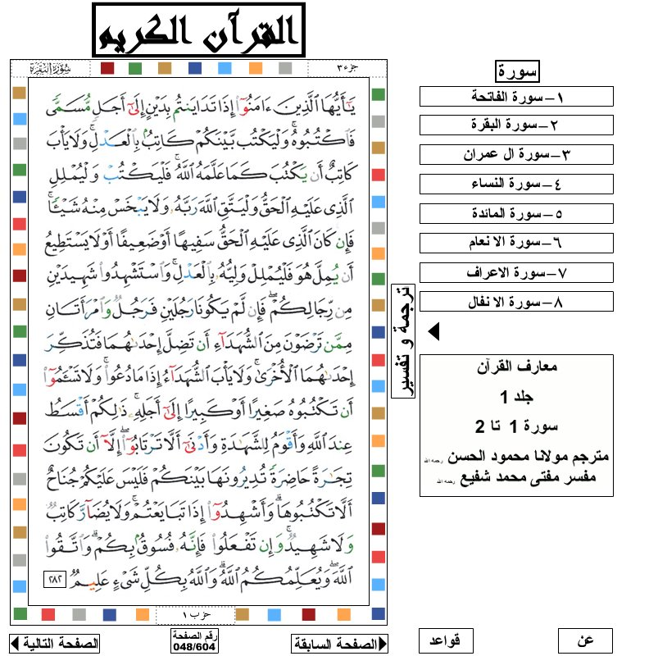
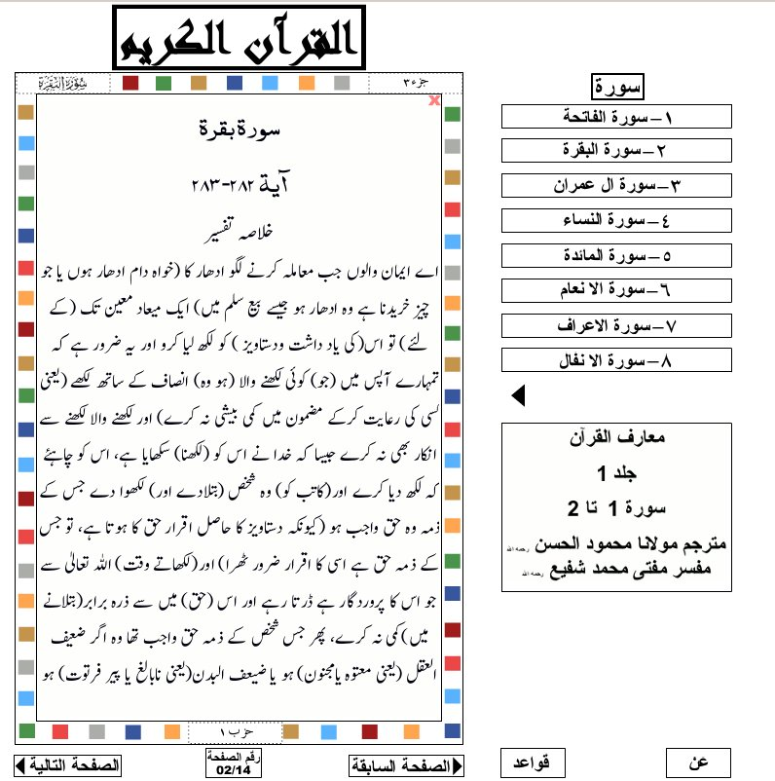
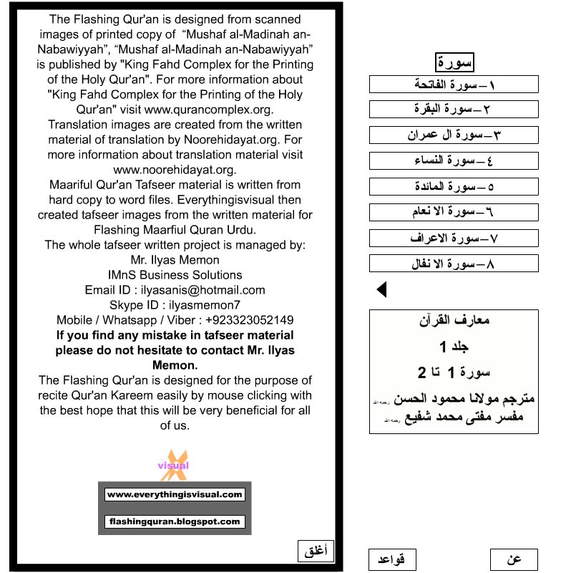
DOWNLOAD

__._,_.___
Reply via web post | Reply to sender | Reply to group | Start a New Topic | Messages in this topic (1)
Please remember us all in your supplication. Ya Allah swt. maneuver us to the right way and give us the firmness to hold the Truth in the light of Qur'an and Sunnah, and to forsake all things which are in inconsistency to the Al-Qur'an and Sunnah of RasoolAllah saws. (Ameen)
("History Islam" - eGroup does not bear any responsibility of any opinion
posted by the members of this group).
[It will be viewed good when you encode your page in Unicode (UTF-8)]
VISIT YOUR GROUP
- New Members 1
• Privacy • Unsubscribe • Terms of Use
Show message history

Assalam-o-alaikum(2)
Madiah Butt
To Me
15 Mar
Assalam-o-alaikum Dr Umar Azam,

A friend is doing Istikhara for marriage. She has seen different dreams, but does not understand them:
- she has washed her hairs and sees that she has got two block of hairs on both sides of her head and in
between no hair, she becomes so worried and scared, she runs to her mom and asks see what happened and
her mom says no there is nothing, then she feels her hair and it is normal
- she has seen seekh kebab with little litlle haradhanja and harimirchen in it
- she has seen something gold with blue and red pearls in it, then after everything becomes black
- she has seen she is in a room and everyone has to show their nudity, but she tries to cover herself, because
she does not want to show it, she is trying to cover it with a black kapra
- she and her family are sitting together, talking for her marriage, then she sees a very beautiful green landscape,
but then suddenly she sees a helicopter is falling down, zameen sab ander ja rahi hai, she is trying to run on a cycle
which is not in good condition
- she sees a friend of her standing in green black clothes
It is a bit confusing and she does not know what she should understand of it.
If you can make things clear please.

Thanks a lot
Reply, Reply All or Forward | More
Me
To Madiah Butt
15 Mar
WA LAIKUM SALAM, MADIAH

THESE DREAMS ARE TELLING HER THAT THE TIME IS NOT RIGHT FOR MARRIAGE JUST YET. SHE FEELS THAT HER LIFE HAS MINOR DIFFICULTIES HERE AND THERE. ALSO, SHE NEEDS TO BE MORE RELIGIOUS AND TRUSTWORTHY TO BE ABLE TO GET A GOOD RISHTA.

ASK HER TO READ MY PRACTICAL ISLAMIC ADVICE ON WWW.DR-UMAR-AZAM.COM

Dr Umar Azam

Assalam-o-alaikum(3)
Madiah Butt
To Me
11 Mar
Assalam-o-alaikum Dr Umar Azam,

Last night I saw a dream and I am really wondering what it means.

I just came in with my mom, an aunty to visit another aunty. We are doing salam and hug. In my mind, we are
there to talk and look for the marriage of my sister. In real life, we are looking for someone to marry her.
Then we sit down and in my mind comes that we are here, because someone has died. Afsoos ke
liye aye hain. May donon haath uthati hon, jaise dua ke liye uthate hain, my both hands are looking very
beautiful, I am wearing a silver ring with diamond. Mere sar pe white dupatta hai.
I feel very good and confident and sakoon jab haath uthati hon dua ke liye aur parhna shuru karne ke liye.
When putting hands together, I read Darood Shareef, Surah Al Fatiha and again Darood Shareef. It is supposed to
be for the person who died.
Then the aunty in whose house we are, is saying that I am wearing very nice earrings and
I am trying to think which one I am wearing. I see wearing myself white rose clothes, then I think I will be wearing those
colorful earrings with pink yellow blue green in it.
Then a little girl comes to sit next to me. I am hugging and kissing her and thinking I wished I had a kid as well.

Allah Hafiz

Reply, Reply All or Forward | More
Me
To Madiah Butt
11 Mar
WA LAIKUM SALAM, MADIAH
CONGRATULATIONS! IF YOUR DREAM TURNS OUT TO BE TRUE, IT MEANS THAT YOUR SISTER WILL GET MARRIED AND THEN YOU WON'T SEE MUCH OF HER BECAUSE OF THE DEMANDS OF HER MARRIED LIFE [DEATH]. INSHA'ALLAH, THE MARRIAGE WILL BE BLESSED [SURAH FATIHA, DUROOD SHARIF, MAKING DUA] AND A HAPPY STATE OF AFFAIRS [WHITE CLOTHES, COLOURFUL EARRINGS, SILVER RING WITH DIAMOND]. SO THE NEXT YEAR [LITTLE GIRL] WILL BE HAPPY FOR YOUR SISTER.

ALLAH'S BLESSINGS ON YOU AND YOUR FAMILY.

Dr Umar Azam

See these Websites and sign my Guestbooks please:

www.dr-umar-azam.com

www.dr-umar-azam.co.uk

http://dr-umar-azam.weebly.com
Show message history
Reply, Reply All or Forward | More
Madiah Butt
To Me
12 Mar
Assalam-o-alaikum DR Umar Azam,

Thanks a lot for the dream explanation! It is really good news inshAllah.

Allah Hafiz

Islamic Dream Interpretation(8)
danish haque
To Me
26 Jan
Salam Wale Kum,
I saw a dream in which my complete family is tense. We all are sitting in front of our maternal grandmother who is also deceased. Quran Sharif was opened in front of her. And she told us to recite Darood Sharif.
Regards
Danish
Reply, Reply All or Forward | More
danish haque
To Me
26 Jan
Salam Wale Kum,
I saw a dream in which four member of my family(Myself, Sister, Brother, did not remember its was my Father or Mother) is tense. We all are sitting in front of our maternal grandmother who is also deceased. Quran Sharif was opened in front of her. She told us to recite Darood Sharif and your problem will go away.
Regards
Danish
Show message history
Reply, Reply All or Forward | More
Me
To danish haque
26 Jan
WA LAIKUM SALAM, DANISH
THE ONES WHO HAVE DIED CANNOT SPEAK LIES. THEREFORE, WHAT YOUR MATERNAL GRANDMOTHER SAYS IS TRUE. YOUR FAMILY HAVE SOME PROBLEMS OF SOME KIND, SO YOUR FAMILY SHOULD READ THE HOLY QURAN AND BLESS THE PROPHET S.AW. SO THAT ALLAH CAN HAVE MERCY ON ALL OF YOU, AND
THROUGH THE BARKAT OF THE PROPHET S.A.W.. SO YOUR DREAM SEEMS TO BE LITERAL, IN OTHER WORDS, IT DOESN'T REQUIRE INTERPRETATION.
Dr Umar Azam

Show message history
Reply, Reply All or Forward | More
danish haque
To Me
1 Mar
Salam Wale Kum,

Yesterday I saw a dream in which I was sitting with my father for Eid Namaz. Before the eid namaz there was an announcement that will have a janaza nemaz first and then will have eid nemaz, please gather other side of ground.I have moved to offer janaza nemaz but my father remain sited there and he did not even stopped me.Once the crowd gather for janaza nemaz people at front row distributed alcohol to which I was surprised and stunned.Once the janaza nemaz was over and turned towards where my father was sitting, I found there was another jamayat which completed Eid Namaz.After that I saw I am in mosque where I am complaining to a Imam about the Imam who led janaza namz that these people had distributed alcohol during namaz.
That Imam was also present in mosque.But I did not saw face of Imam who led janaza namaz.

Regards
Danish
Show message history
Reply, Reply All or Forward | More
danish haque
To Me
1 Mar

On Saturday, 1 March 2014 5:45 PM, danish haque <danishhaque@yahoo.co.in> wrote:
Salam Wale Kum,

Yesterday I saw a dream in which I was sitting with my father for Eid Namaz. Before the eid namaz there was an announcement that will have a janaza nemaz first and then will have eid nemaz, please gather other side of ground.I have moved to offer janaza nemaz but my father remain sited there and he did not even stopped me.Once the crowd gather for janaza nemaz people at front row distributed alcohol to which I was surprised and stunned.Once the janaza nemaz was over and turned towards where my father was sitting, I found there was another jamayat which completed Eid Namaz.After that I saw I am in mosque where I am complaining to a Imam about the Imam who led janaza namz that these people had distributed alcohol during namaz.
That Imam was also present in mosque.But I did not saw face of Imam who led janaza namaz.Alcohol was made of Grapes

Regards
Danish

On Sunday, 26 January 2014 11:29 PM, DR UMAR AZAM <dr_umar_azam@yahoo.co.uk> wrote:
WA LAIKUM SALAM, DANISH

THE ONES WHO HAVE DIED CANNOT SPEAK LIES. THEREFORE, WHAT YOUR MATERNAL GRANDMOTHER SAYS IS TRUE. YOUR FAMILY HAVE SOME PROBLEMS OF SOME KIND, SO YOUR FAMILY SHOULD READ THE HOLY QURAN AND BLESS THE PROPHET S.AW. SO THAT ALLAH CAN HAVE MERCY ON ALL OF YOU, AND THROUGH THE BARKAT OF THE PROPHET S.A.W.. SO YOUR DREAM SEEMS TO BE LITERAL, IN OTHER WORDS, IT DOESN'T REQUIRE INTERPRETATION.

Dr Umar Azam
Reply, Reply All or Forward | More
danish haque
To Me
1 Mar
Salam Wale Kum,

Yesterday I saw a dream in which I was sitting with my father for Eid Namaz. Before the eid namaz there was an announcement that will have a janaza nemaz first and then will have eid nemaz, please gather other side of ground.I have moved to offer janaza nemaz but my father remain sited there and he did not even stopped me.Once the crowd gather for janaza nemaz people at front row distributed alcohol to which I was surprised and stunned.Once the janaza nemaz was over and turned towards where my father was sitting, I found there was another jamayat which completed Eid Namaz.After that I saw I am in mosque where I am complaining to a Imam about the Imam who led janaza namz that these people had distributed alcohol during namaz.
That Imam was also present in mosque.But I did not saw face of Imam who led janaza namaz.Alcohol was made of Grapes

It was my assumption that its alcohol by its look and the bottel from it is poured.On bottel it was written it is made of Grapes.
Show message history
Reply, Reply All or Forward | More
danish haque
To Me
2 Mar
Salam Wale Kum,

I can understand the first part but not able to connect with 2nd and 3rd section from my life.

A PHASE IN YOUR LIFE MAY BE COMING WHERE YOU MOVE AWAY FROM YOUR DAD [JANAZAH] --- I am already leaving away from my father.Is it like relationship will turn bad. Or will I leave my father and moved to other world.
SOME MUSLIMS AND THEIR LEADERS TODAY COMMIT SIN [ALCOHOL].--Am I in influence of such leader or will be.
On Sunday, 2 March 2014 4:12 AM, DR UMAR AZAM <dr_umar_azam@yahoo.co.uk> wrote:
WA LAIKUM SALAM, DANISH

YOUR DREAM SEEMS TO BE TELLING YOU THAT YOU HAVE A HAPPY RELATIONSHIP WITH YOUR FATHER [EID], A PHASE IN YOUR LIFE MAY BE COMING WHERE YOU MOVE AWAY FROM YOUR DAD [JANAZAH] AND SOME MUSLIMS AND THEIR LEADERS TODAY COMMIT SIN [ALCOHOL].

Dr Umar Azam

Reply, Reply All or Forward | More
Me
To danish haque
2 Mar
THAT'S LIKE ASKING ME TO PREDICT THE FUTURE, DANISH. I DON'T KNOW. ONLY ALLAH KNOWS THE FUTURE. BUT, YES, IT COULD BE THAT YOU MOVE TO A DIFFERENT AREA AWAY FROM YOUR FATHER, SO YOU CAN'T SEE HIM MUCH. AND YOU COULD COME INTO CONTACT WITH SOME HYPOCRITICAL IMAM OR YOUR DREAM COULD BE TELLING YOU OF THE GENERAL SITUATION AMONG CERTAIN 14 TH ISLAMIC-CENTURY 'RELIGIOUS' FIGURES.
Dr Umar Azam

Re: Islamic Dream Interpretation
Me
To danish haque
1 Mar
WA LAIKUM SALAM, DANISH

YOUR DREAM SEEMS TO BE TELLING YOU THAT YOU HAVE A HAPPY RELATIONSHIP WITH YOUR FATHER [EID], A PHASE IN YOUR LIFE MAY BE COMING WHERE YOU MOVE AWAY FROM YOUR DAD [JANAZAH] AND SOME MUSLIMS AND THEIR LEADERS TODAY COMMIT SIN [ALCOHOL].

Dr Umar Azam

Your honest opinion needed!
Me
To shahidphp@gmail.com
22 Jan
SALAM, SHAHI

THANK YOU FOR FILLING IN MY FEEDBACK FORM BUT YOU FORGOT SOMETHING.
WHAT DO YOU THINK OF MY RESOURCES SITE: http://dr-umar-azam.weebly.com

Dr Umar Azam

PDF English Islamic Books 1-10(2)
islam muslim
To Medrshaziashahid@yahoo.commoizuddin_khan1987@yahoo.com and 40 More...
19 Jan
List of English Books (1-20)
# | Book Title / Link
1 | Rights of Parents (English) (Mirza Ehteshamuddin Ahmed)3.4 mb 27 pageshttp://d1.islamhouse.com/data/en/ih_books/single/en_Rights_of_Parents.pdf  or  http://ia601603.us.archive.org/25/items/RightsOfParents/Parents.PDF  or  www.scribd.com/doc/60810874/The-Rights-of-Parents  or  http://en.islamstory.com/uploads/multimedia/books/muslim_character/rights_of_parents.pdf
2 | The rights of Parents (Shaykh Muhammad Saleh Al Uthaymeen)  http://abdurrahman.org/character/essentialrights.html#3
3 | Kindness to Parents- Abdul Malik Al-Qasim-4 mb-77 Pages  http://www.kalamullah.com/kindness-to-parents.html
4 | Honoring Parents- (Shaikh Muhammed Salih Al-Munajjid) 1 mb - 72 pages  http://www.kalamullah.com/Books/Honouring%20Parents.pdf

# | Book Title / Link
5 | Essential Rights- (Shaykh Muhammad Saleh Al Uthaymeen)  http://abdurrahman.org/character/essentialrights.html
6 | Parent-Child Relationship in Islam –(Dr. I.A. Arshad)  http://www.islam101.com/sociology/parchild.htm
7 | The Rights of Parents and Children in Islam(navedz)  http://navedz.wordpress.com/2009/06/10/rights-of-parents-and-children-in-islam
8 | Rights of Children(Mirza Ehteshamuddin Ahmed) 4.3 mb 31 pages  http://d1.islamhouse.com/data/en/ih_books/single/en_Rights_of_Children.pdf  or  http://ia801604.us.archive.org/13/items/RightsOfChildren/Children.PDF  or  www.scribd.com/doc/60811083/Rights-of-Children  or  http://en.islamstory.com/uploads/multimedia/books/muslim_character/rights-of-children.pdf
9 | The rights of Children in Islam (Shaykh Muhammad Saleh Al Uthaymeen)  http://www.missionislam.com/family/childrensrights.htm
10 | Child Education in Islam- (Shaikh Abdullah Nasih Ulwan) 24mb- 422 Pages  http://www.kalamullah.com/Books/Child%20Education%20in%20Islam.pdf
Reply, Reply All or Forward | More
Me
To islam muslimdrshaziashahid@yahoo.commoizuddin_khan1987@yahoo.com and 40 More...
19 Jan
JAZAKALLAH. FREE SOFT COPY OF QURAN AVAILABLE FROM ME IN ANY LANGUAGE. PLEASE EMAIL ME. DR UMAR
Dr Umar Azam

Mail - Umar Azam(2)
SMIOK
To Me
19 Sep 2013
Hi Umar Azam

In an effort to focus on emails that still have relevance I looked up yours and wondered if still of interest? The original mail is copied below my signature.

Do advise if we still need to liaise.

Regards,

Imran Owais Kazmi
Chief Thinking Officer, CRS Cube www.crscube.com
Cell (UAE) +971 55 8094119 (US) +1949 556 4217 BBM 286C717A
about.me/imranokazmi

From: Umar Azam
To: iakhan@technokraft.net; iali_cam@yahoo.com; ibinahoro56@msn.com; ibrahim_abdul@live.com; ibrajr@usa.com; ihossain@icddrb.org; ijaz@umerindustry.com; ijaz79@cyber.net.pk; ikraamt@lithotech.co.za; ikram.elahi@ecs.com.pk; imanco@intnet.mu; imports@designersw
Subject: 27TH RAMADAN

Message:

Assalamu Alaikum,

Thank you for your Requests….

……………………………………………………………………………………………………………………

Me
To imran.kazmi@ahappyworld.info
20 Sep 2013
WA LAIKUM SALAM,

THAT DEPENDS ON THE QUESTION OF WHETHER YOU STILL WANT THE DUA FOR THE LAYLAT-AL-QADR, BR IMRAN. BUT YOU SENT YOUR EMAIL AFTER THE HOLY MONTH OF RAMADAN HAS GONE FOR THIS YEAR! NOT TO WORRY, I'LL SEND YOU VARIOUS VALUABLE, HOLY RESOURCES TONIGHT, ANYHOW.

DR UMAR

thanks for taweez. need help(2)
tawseef masoud
To Me
15 Sep 2013
ASAK. please send me a powerful working taweez to break illegal relationship between a boy and girl. please sir i beg.
Reply, Reply All or Forward | More
Me
To tawseef masoud
15 Sep 2013
WA LAIKUM SALAM, BR TAWSEEF

I'M AN ISLAMIC SCHOLAR, NOT A PIR. PLEASE USE THIS LINK:

http://www.roohanielaj.com/contacts.html

MAY YOU FIND A WAY OUT OF THIS UGLY PREDICAMENT WITH THE WILL OF ALLAH MOST HIGH. AMEEN.

DR UMAR

